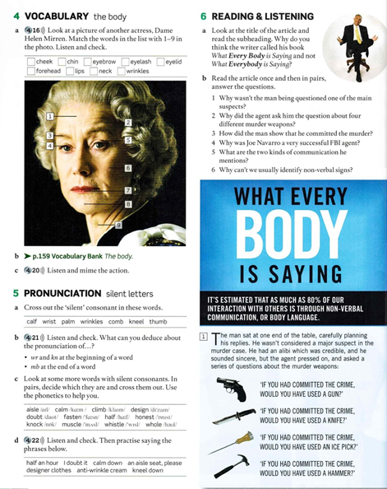

**4.a)**

1. forehead
2. eyebrow
3. eyelid
4. eyelash
5. wrinkles
6. cheek
7. lips
8. chin
9. neck

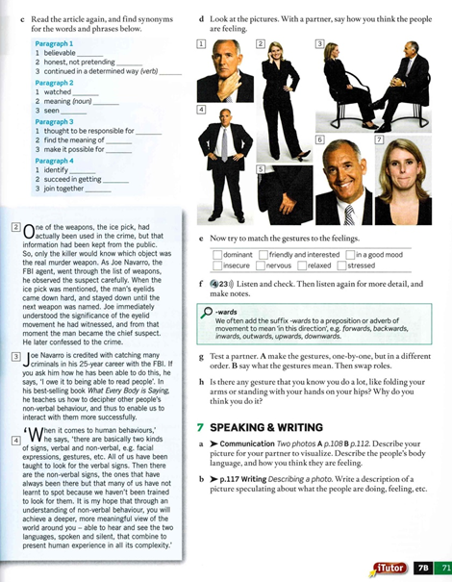

**C)**

Par. 1

1. credible
2. sincere
3. pressed on

Par. 2

1. observed
2. significance
3. witnessed

Par. 3

1. credited with
2. decipher
3. enable

Par. 4

1. spot
2. achieve
3. combine

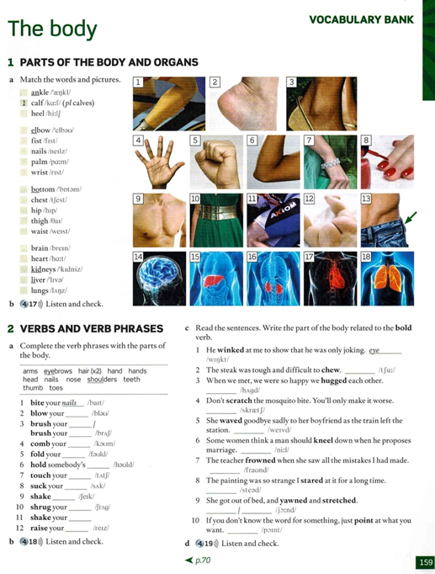

**1.a)**

1. calf
2. heel
3. ankle
4. palm
5. fist
6. elbow
7. wrist
8. nails
9. chest
10. waist
11. thigh
12. bottom
13. hip
14. brain
15. liver
16. kidneys
17. heart
18. lung

**2.a)**

1. bite your nails
2. blow your nose
3. brush your hair , brush your teeth
4. comb your hair
5. fold your arms
6. hold somebody’s hand
7. touch your toes
8. suck your thumb
9. shake hands
10. shrug your shoulders
11. shake your head
12. raise your eyebrows

**2.c)**

1. eye
2. teeth
3. arms
4. nails
5. hand
6. knee
7. forehead
8. eyes
9. mouth / arms
10. finger

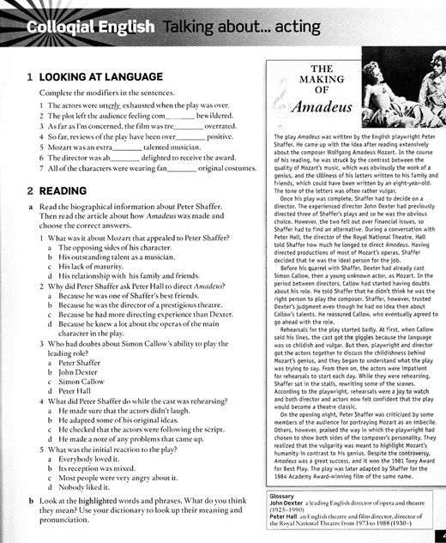

**1 Looking at language**

1. utterly
2. completely
3. tremendously
4. overwhelmingly
5. extraordinary
6. absolutely
7. fantastically

**2 Reading**

1. a
2. d
3. c
4. b
5. b

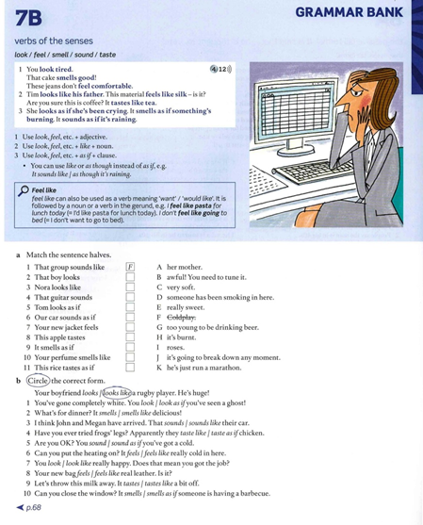

**a)**

1. f
2. g
3. a
4. b
5. k
6. j
7. c
8. e
9. d
10. i
11. h

**b)**

1. look as if
2. smells
3. sounds like
4. taste like
5. sound as if
6. feels
7. look
8. feels like
9. tastes
10. smells as if

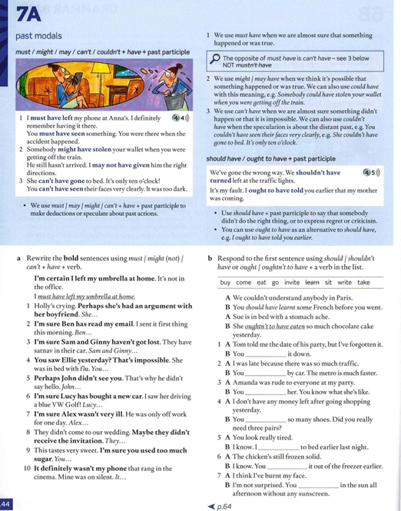

**a**

1. She might have had an argument with her boyfriend.
2. Ben must have read my email.
3. Sam and Ginny couldn’t have gotten lost.
4. You couldn’t have seen Ellie yesterday.
5. John might not have seen you.
6. Lucy must have bought a new car.
7. Alex couldn’t have been very sick.
8. They might not have received the invitation.
9. You must have used too much sugar.
10. It couldn’t have been my phone.

**b**

1. You should have to have written it down.
2. You shouldn’t have come by car.
3. You shouldn’t have invited her.
4. You shouldn’t have bought so many shoes.
5. I should have to have gone to bed earlier last night.
6. You should have to have taken it out of the freezer earlier.
7. You shouldn’t have sat in the sun all afternoon
8. She shouldn’t have eaten so much chocolate cake yesterday.

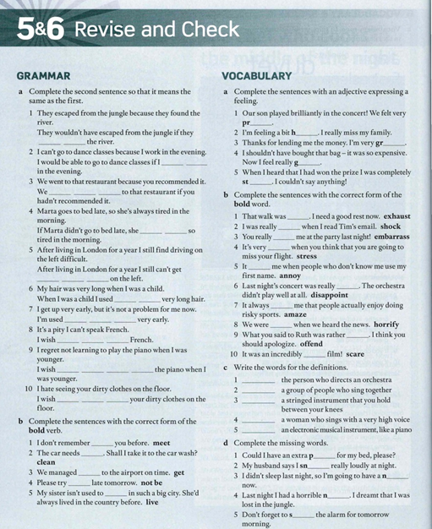

**GRAMMAR**

**a)**

1. hadn’t found
2. didn’t work
3. wouldn’t have gone
4. wouldn’t be
5. used to driving
6. to have
7. to getting up
8. I could speak
9. I’d learned to play
10. you wouldn’t leave

**b)**

1. meeting
2. cleaning
3. to get
4. not to be
5. living

**VOCABULARY**

**a)**

1. proud
2. homesick
3. grateful
4. guilty
5. stunned

**b)**

1. exhausting
2. shocked
3. embarrassed
4. stressful
5. annoys
6. disappointing
7. amazes
8. horrified
9. offensive
10. scary

**c)**

1. conductor
2. choir
3. cello
4. soprano
5. keyboard

**d)**

1. pillow
2. snore
3. nap
4. nightmare
5. set

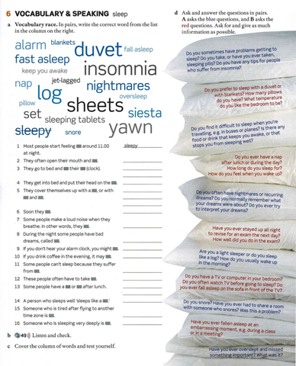

**a)**

1. sleepy
2. yawn
3. alarm
4. pillow
5. comforter, sheets, blankets
6. fall asleep
7. snore
8. nightmares
9. oversleep
10. keep you awake
11. insomnia
12. sleeping pills
13. siesta, nap
14. log
15. jet-lagged
16. fast asleep

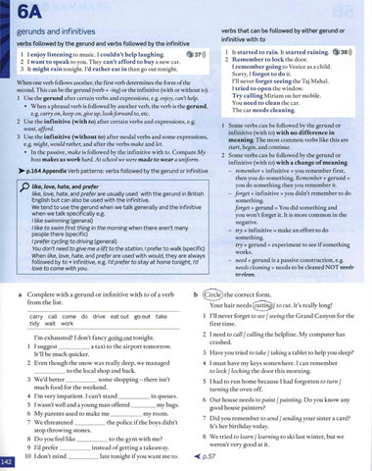

**a)**

1. taking
2. to drive
3. do
4. waiting
5. to carry
6. clean
7. to call
8. coming
9. eating out
10. working

**b)**

1. seeing
2. to call
3. taking
4. locking
5. to turn
6. painting
7. to send
8. to learn